Module 9

9.2 Assignment
Course: CSD325 – 340A
Prepared By: Mirach Erkol and James Buzzell
Date of Report: 11/23/2025

Mikey5007/csd-325: csd-325

9.2 Assignment: Screenshot of API Tutorial Execution
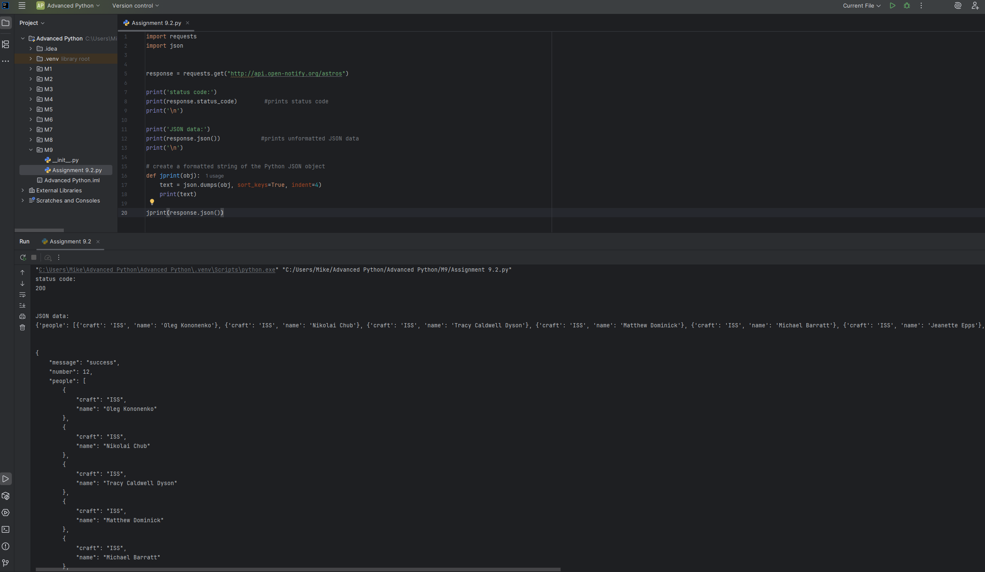

9.2 Assignment: Program that uses the market API for one of my favorite online games to look up item data.
